`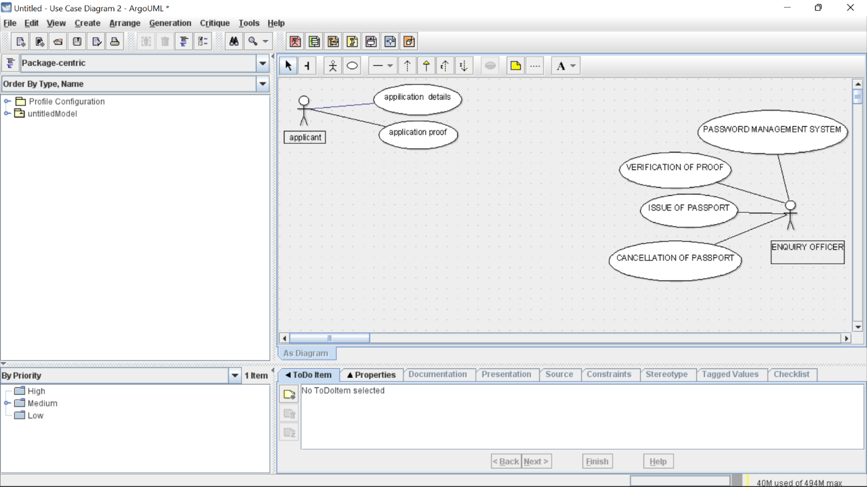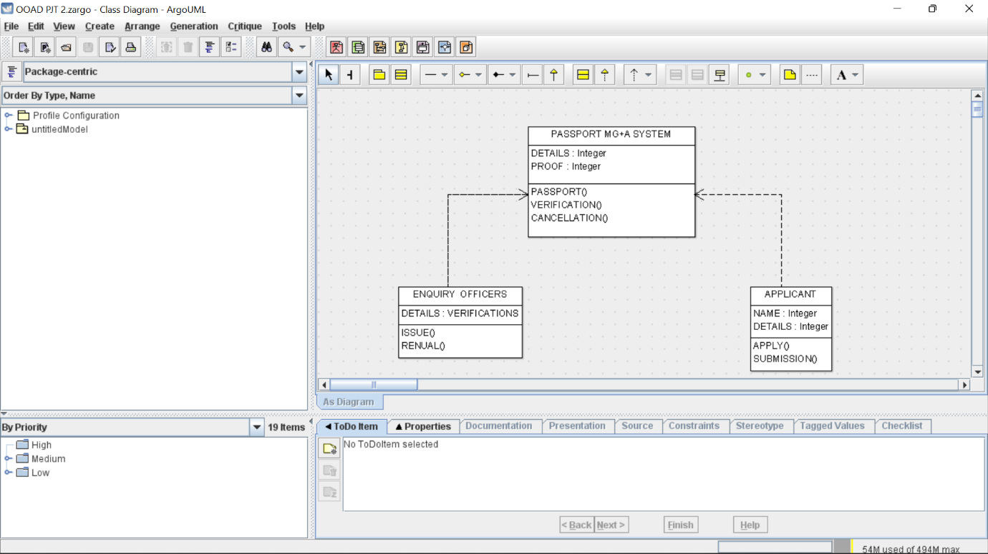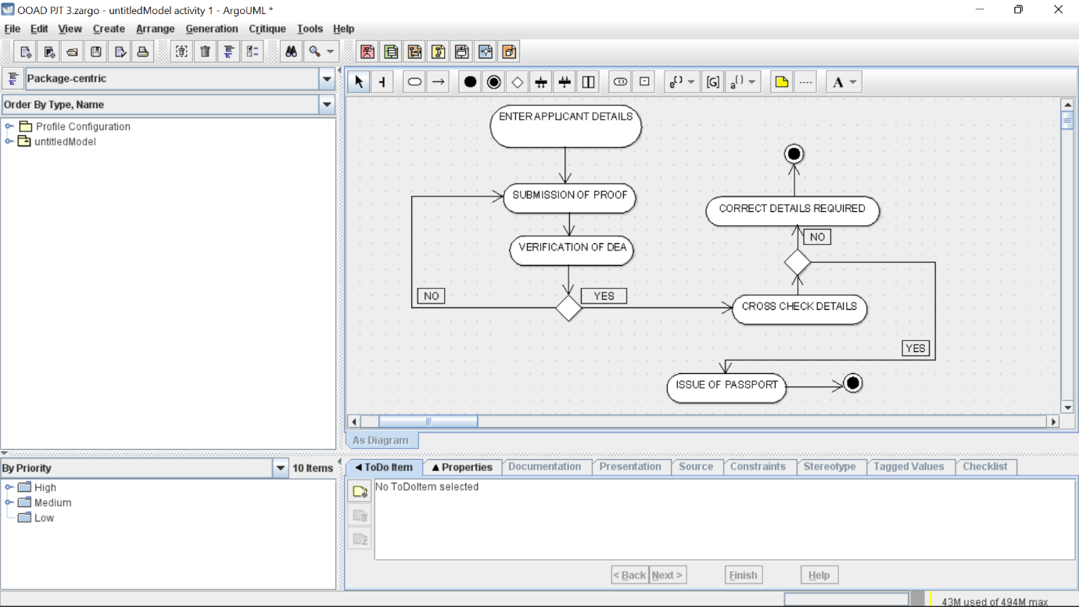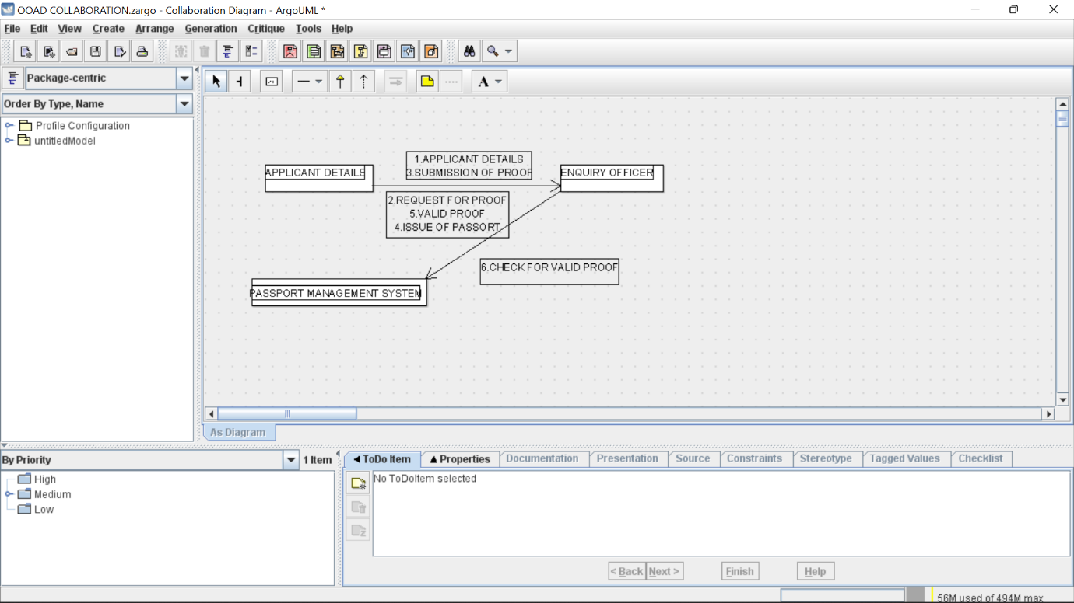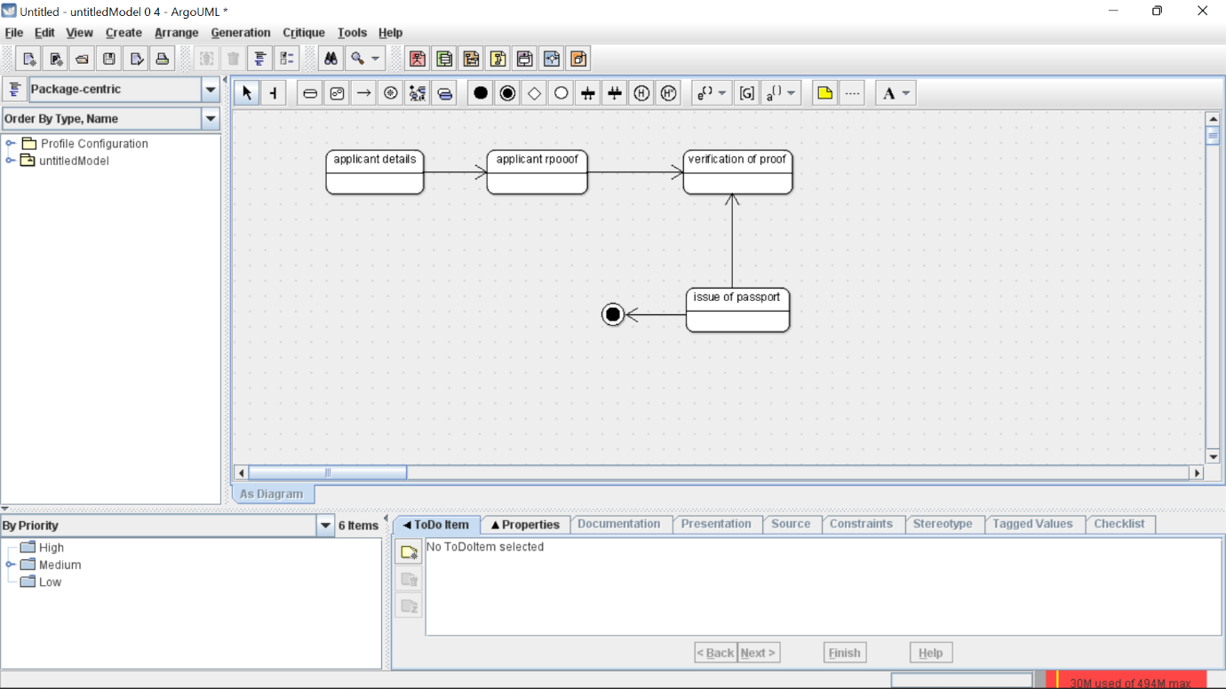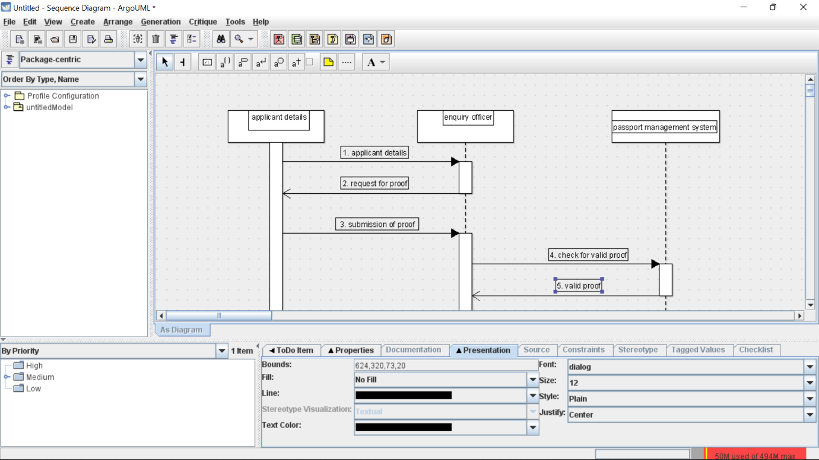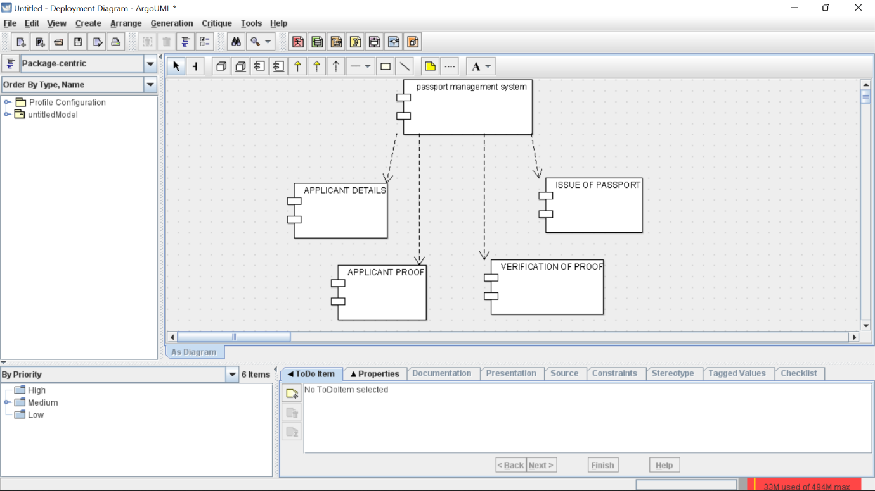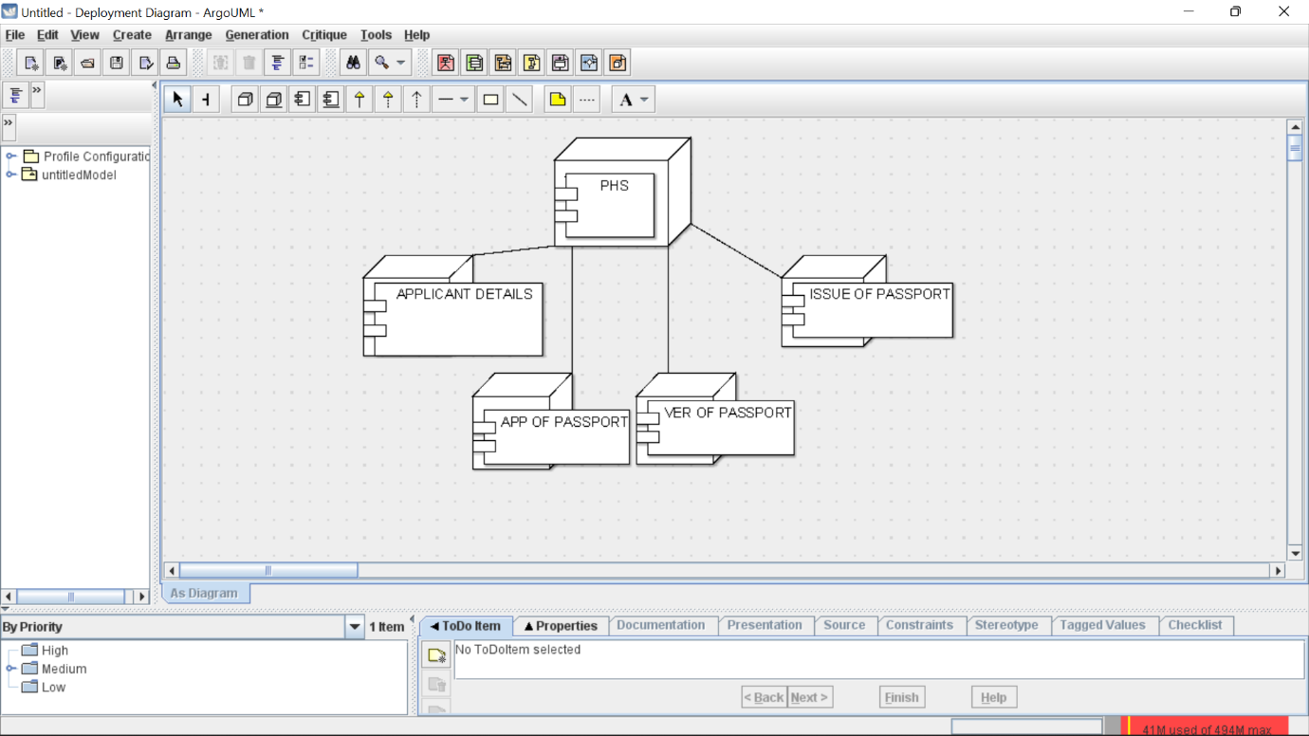

SKELETON CODE

public class APPLICANT {

public Integer NAME;

private Integer DETAILS;

private void APPLY() {

}

private void SUBMISSION() {

}

}

public class ENQUIRY OFFICERS {

private VERIFICATIONS DETAILS;

private void ISSUE() {

}

private void RENUAL() {

}

}

public class PASSPORT MG+A SYSTEM {

private Integer DETAILS;

public Integer PROOF;

private void PASSPORT() {

}

private void VERIFICATION() {

}

public void CANCELLATION() {

}

}